Revised Draft Technical Memorandum |  | 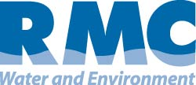
Merced IRWM Plan Development
Subject: | Climate Change Impacts on Merced County and Proposed Adaptations and Mitigation Strategies
Prepared For: | Merced IRWMP Regional Advisory Committee
Prepared by: | RMC Water and Environment
Date: | December 2012

Climate Change

Introduction
There is mounting scientific evidence that global climate conditions are changing and will continue to change as a result of the continued build-up of greenhouse gases (GHGs) in the Earth’s atmosphere. Changes in climate can affect municipal water supplies through modifications in the timing, amount, and form of precipitation, as well as water demands and the quality of surface runoff. These changes can affect all elements of water supply systems, from watersheds to reservoirs, conveyance systems, and treatment plants.
Planning for and adapting to anticipated changes in climate will be essential to ensuring water supply reliability for all users and to protecting sensitive infrastructure against more frequent and extreme precipitation and wildfire events. This technical memorandum (TM) summarizes anticipated climate change impacts on the State of California and the Merced Integrated Regional Water Management (IRWM) region, evaluates the impacts of those changes with regard to water resource management, assesses the vulnerability of the region to anticipated climate change impacts, and provides recommended adaptation and mitigation strategies to address uncertainty and reduce GHG emissions. In addition, a plan for ongoing data collection to fill data gaps and monitor the frequency and magnitude of local hydrologic and atmospheric changes is provided.

Statewide Observation and Projections
Indications of climate change have been observed over the last several decades throughout California. Statewide average temperatures have increased by about 1.7ºF from 1895 to 2011, with the greatest warming in the Sierra Nevada (Moser et al. 2012). Although the State’s weather has followed the expected pattern of a largely Mediterranean climate throughout the past century, no consistent trend in the overall amount of precipitation has been detected, except that a larger proportion of total precipitation is falling as rain instead of snow (Moser et al. 2012).
Multiple models have been developed and run to evaluate global and regional climate change impacts. Global Climate Models (GCMs) have been used to simulate a range of potential future GHG emission scenarios, reflecting possible population increases and human behavioral patterns. The Intergovernmental Panel on Climate Change (IPCC) has established the A2 and B1 scenarios, which represent a middle range of possible emissions. The A2 scenario is characterized by an increasing population, regionally-oriented economic development and independently operating, self-reliant nations. In the A2 scenario, economic growth is uneven, leading to a growing income gap between developed and developing parts of the world.
The B1 scenario assumes a more integrated and ecologically friendly future, and reflects a high level of environmental and social consciousness combined with global cooperation for sustainable development. This scenario is characterized by rapid economic growth and movement toward a service and information economy. It also assumes reductions in materials intensity and the introduction of clean and resource-efficient technologies combined with an emphasis on global solutions to economic, social and environmental stability.
Since the IPCC released these scenarios in 2000, the world has followed a “business as usual” emissions pathway (Figure 1). This most closely resembles the A2 scenario, although temperature changes over the next 30 to 40 years will be largely determined by past emissions. After that point, mid-century temperature projections clearly diverge for the A2 and B1 scenarios.
Figure 1: IPCC Climate Change Scenarios
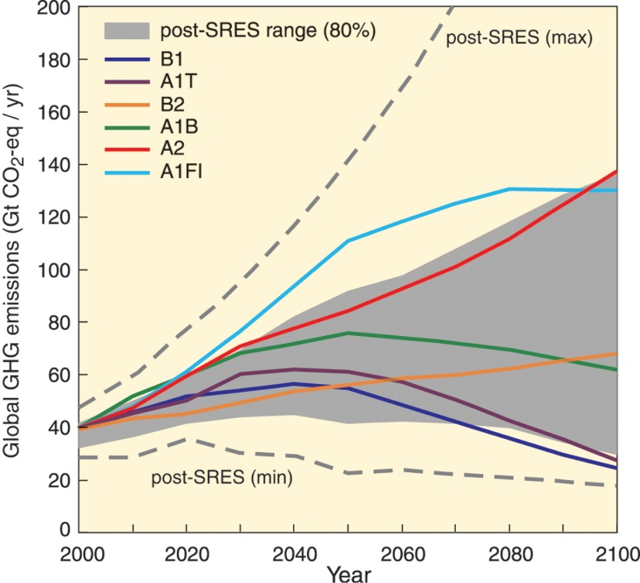
Source: IPCC 2007

Temperature and Precipitation Changes
While California’s average temperature has increased by 1ºF in the last one hundred years, trends are not uniform across the state. The Central Valley has actually experienced a slight cooling trend in the summer, likely due to an increase in irrigation (CEC 2008). Higher elevations have experienced the highest temperature increases (DWR 2008). Many of the state’s rivers have seen increases in peak flows in the last 50 years (DWR 2008).
GCMs project that in the first 30 years of the 21st century, overall summertime temperatures in California will increase by 0.9 to 3.6ºF (CAT 2009) and average temperatures will increase by 3.6 to 10.8ºF by the end of this century (Cayan et al. 2006). Increases in temperature are not likely to be felt uniformly across California. Models generally project that warming will be greater in California in the summer than in the winter (CAT 2009) and inland areas will experience more extreme warming than coastal areas (CNRA 2009). These non-uniform warming trends are among the reasons that regional approaches to addressing climate change are important.
While historical trends in precipitation do not show a statistically significant change in average precipitation over the last century (DWR 2006), regional precipitation data show a trend of increasing annual precipitation in Northern California (DWR 2006) and decreasing annual precipitation throughout Southern California over the last 30 years (DWR 2008). A key change in precipitation patterns has been more winter precipitation falling as rain instead of snow (CNRA 2012), leading to increased streamflow in the winter and decreased streamflow in the spring and summer, when water demands are the greatest. This increased streamflow variability could lead to increased risks of flooding, levee failure, saline water intrusion and flood- or drought-induced habitat destruction.
While temperature projections exhibit high levels of agreement across various models and emissions scenarios, projected changes in precipitation are more varied. Taken together, downscaled GCM results show little, if any, change in average precipitation for California before 2050 (DWR 2006), with a drying trend emerging after 2050 (BOR 2011, CCSP 2009). While little change in precipitation is projected by the GCMs as a group, individual GCM results are considerably varied. Climate projections therefore imply an increase in the uncertainty of future precipitation conditions.

Sea-level Rise, Snowpack Reduction, and Extreme Events
In the last century, the California coast has seen a sea level rise of seven inches (DWR 2008). The average April 1st snowpack in the Sierra Nevada region has decreased in the last half century (Howat and Tulaczyk 2005, CCSP 2008), and wildfires are becoming more frequent, longer, and more widespread (CCSP 2008).
As the climate warms, the Sierra Nevada’s snowpack (a primary storage mechanism for California’s water supply) is anticipated to continue to shrink. Based on simulations conducted to date, Sierra Nevada snowpack is projected to shrink by 30% between 2070 and 2099, with drier, higher warming scenarios putting that number as high as 80% (Kahrl and Roland-Holst 2008). Additionally, extreme events are expected to become more frequent, including wildfires, floods, droughts, and heat waves. In contrast, freezing spells are expected to decrease in frequency over most of California (CNRA 2009). While GCM projections may indicate little, if any, change in average precipitation moving into the future, extreme precipitation events are expected to become more commonplace (CBO 2009). The combination of drier and warmer weather compounds expected impacts on water supplies and ecosystems in the Southwestern United States (CCSP 2009) with wildfires expected to continue to increase in both frequency and severity (CCSP 2009).
Figure 2: Projected Snowpack Changes in the Sierra Nevada
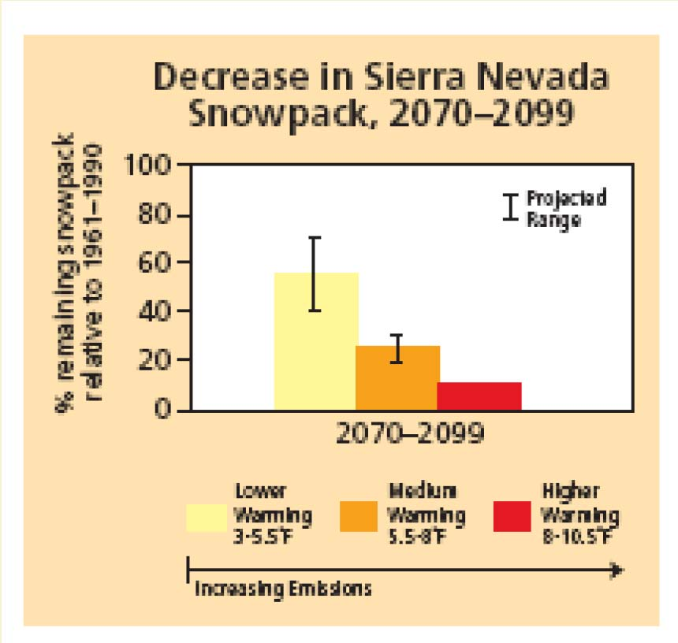
Source: Hopmans et al. 2008

Legislative and Policy Context
In order to address currently-predicted climate change impacts to California’s water resources, the California Department of Water Resources’ (DWR’s) IRWM Grant Program Guidelines require that IRWM Plans describe, consider and address the effects of climate change on their region, and consider reducing GHG emissions when developing and implementing projects. Part of this process involves framing the IRWM analysis and response actions in the context of State legislation and policies that have been formed to address climate change. The following summarizes the legislation and policies that were considered as part of this IRWM Plan.

Executive Order (EO) S-3-05 (2005)
EO S-3-05, signed on June 1, 2005 by Governor Arnold Schwarzenegger, is a key piece of legislation that has laid the foundation for California’s climate change policy. This legislation recognized California’s vulnerabilities to the impacts of climate change, including vulnerabilities of water resources. EO S-3-05 established three GHG reduction targets for California:
- By 2010, reduce GHG emissions to 2000 California levels
- By 2020, reduce GHG emissions to 1990 California levels
- By 2050, reduce GHG emissions to 80 percent below 1990 California levels

In addition to establishing GHG reduction targets for California, EO S-3-05 required the head Secretary of the California Environmental Protection Agency (CalEPA) to establish the Climate Action Team (CAT) for State agencies to coordinate oversight of efforts to meet these targets. As laid out in the EO, the CAT submits biannual reports to the governor and State legislature describing progress made toward reaching the targets.

There are currently 12 sub-groups within CAT, one of which is the Water-Energy group (also known as WET-CAT). WET-CAT was tasked with coordinating the study of GHG effects on California’s water supply system, including the development of GHG mitigation strategies for energy consumption related to water use. Since the adoption of the Assembly Bill 32 Scoping Plan (see the following section), WET-CAT has been working on the implementation and analyses of six water-related measures identified in the Scoping Plan:
- Water Use Efficiency
- Water Recycling
- Water System Energy Efficiency
- Reuse Urban Runoff
- Increase Renewable Energy Production
- Public Goods Charge for Water

Assembly Bill 32: The California Global Warming Solutions Act of 2006 (2006)
Assembly Bill 32 (AB 32), the California Global Warming Solutions Act of 2006, laid the foundation for California’s response to climate change. In 2006, AB 32 was signed by Governor Schwarzenegger to codify the mid-term GHG reduction target established in EO S-3-05 (reduce GHG emissions to 1990 levels by 2020). AB 32 directed the California Air Resources Board (CARB) to develop discrete early actions to reduce GHG emissions by 2007, and to adopt regulations to implement early action measures by January 1, 2010.

Climate Change Scoping Plan (2008)
AB 32 required CARB to prepare a Scoping Plan to identify and achieve reductions in GHG emissions in California. The Climate Change Scoping Plan, adopted by CARB in December 2008, recommends specific strategies for different business sectors, including water management, to achieve the 2020 GHG emissions limit.

Senate Bill 97 (2007)
Senate Bill 97 (SB 97) recognized the need to analyze greenhouse gas emissions as part of the California Environmental Quality Act (CEQA) process. SB 97 directed the Governor’s Office of Planning and Research (OPR) to develop, and the Natural Resources Agency to adopt, amendments to the CEQA Guidelines to address the analysis and mitigation of greenhouse gas emissions. On December 31, 2009, the Natural Resources Agency adopted amendments to the CEQA Guidelines and sent them to the California Office of Administrative Law for approval and filing with the Secretary of State (http://www.ceres.ca.gov /ceqa/guidelines/). The CEQA Guidelines are not prescriptive; rather they encourage lead agencies to consider many factors in performing a CEQA analysis, and maintain discretion with lead agencies to make their own determinations based on substantial evidence.

Managing an Uncertain Future: Climate Change Adaptation Strategies for California’s Water (2008)
DWR, in collaboration with the State Water Resources Control Board (SWRCB), other state agencies, and numerous stakeholders, has initiated a number of projects to begin climate change adaptation planning for the water sector. In October 2008, DWR released the first state-level climate change adaptation strategy for water resources in the United States, and the first adaptation strategy for any sector in California. Entitled Managing an Uncertain Future: Climate Change Adaptation Strategies for California’s Water, the report details how climate change is currently affecting the state’s water supplies, and sets forth ten adaptation strategies to help avoid or reduce climate change impacts to water resources.
Central to these adaptation efforts will be the full implementation of IRWM plans, which address regionally-appropriate management practices that incorporate climate change adaptation. These plans will evaluate and provide a comprehensive, economical, and sustainable water use strategy at the watershed level for California.

Executive Order S-13-08 (2008)
Given the potentially serious threat of sea level rise to California's water supply and coastal resources, and the subsequent impact it would have on our state's economy, population, and natural resources, Governor Schwarzenegger issued EO S-13-08 to enhance the state's management of climate impacts from sea level rise, increased temperatures, shifting precipitation, and extreme weather events. This order required the preparation of the first California Sea Level Rise Assessment Report (by the National Academy of Sciences) to inform the State as to how California should plan for future sea level rise; required all state agencies to consider a range of sea level rise scenarios for the years 2050 and 2100 in order to assess potential vulnerabilities of proposed projects and, to the extent feasible, reduce expected risks and increase resiliency to sea level rise; and required the Climate Action Team to develop state strategies for climate adaptation, water adaptation, ocean and coastal resources adaptation, infrastructure adaptation, biodiversity adaptation, working landscapes adaptation, and public health adaptation.

California Climate Adaptation Strategy (2009)
In response to the passage of EO S-13-08, the Natural Resource Agency wrote the report entitled 2009 California Climate Adaptation Strategy (CAS) to summarize the best known science on climate change impacts in the state, to assess vulnerability, and to outline possible solutions that can be implemented within and across the state agencies to promote climate change resilience. The document outlined a set of guiding principles that were used in developing the strategy, and resulted in the preparation of 12 key recommendations as follows:
- Appoint a Climate Adaptation Advisory Panel (CAAP) to assess the greatest risks to California from climate change and to recommend strategies to reduce those risks, building on the Climate Change Adaptation Strategy.
- Implement the 20x2020 water use reductions and expand surface and groundwater storage; implement efforts to fix Delta water supply, quality and ecosystems; support agricultural water use efficiency; improve statewide water quality; improve Delta ecosystem conditions; and stabilize water supplies as developed in the Bay Delta Conservation Plan.
- Consider project alternatives that avoid significant new development in areas that cannot be adequately protected from flooding, wildfire, and erosion due to climate change.
- Prepare, as appropriate, agency-specific adaptation plans, guidance or criteria.
- For all significant state projects, including infrastructure projects, consider the potential impacts of locating such projects in areas susceptible to hazards resulting from climate change.
- The CAAP and other agencies will assess California’s vulnerability to climate change, identify impacts to state assets, and promote climate adaptation/mitigation awareness through the Hazard Mitigation Web Portal and My Hazards Website, as well as other appropriate sites.
- Identify key California land and aquatic habitats that could change significantly during this century due to climate change.
- The California Department of Public Health will develop guidance for use by local health departments and other agencies to assess mitigation and adaptation strategies, which include impacts on vulnerable populations and communities, and assessment of cumulative health impacts.
- Communities with General Plans and Local Coastal Plans should begin, when possible, to amend their plans to assess climate change impacts, identify areas most vulnerable to these impacts, and develop reasonable and rational risk reduction strategies using the CAS as guidance.
- State fire fighting agencies should begin immediately to include climate change impact information into fire program planning to inform future planning efforts.
- State agencies should meet projected population growth and increased energy demand with greater energy conservation and an increased use of renewable energy.
- New climate change impact research should be broadened and funded.

GHG Reporting Rule (2009)
While California has taken the lead in climate change policy and legislation, there have been several recent developments at the federal level affecting climate change legislation. On September 22, 2009, USEPA released the Mandatory Reporting of Greenhouse Gases Rule (74FR56260, Reporting Rule), which requires reporting of GHG data and other relevant information from large sources and suppliers in the United States. Starting in 2010, facility owners that emit 25,000 metric tons of GHGs or more per year are required to submit to the USEPA an annual GHG emissions report with detailed calculations of facility GHG emissions. These activities will dovetail with the AB 32 reporting requirements in California.

Senate Bill 375 (2008)
The Sustainable Communities and Climate Protection Act of 2008 (Senate Bill [SB] 375) was passed to enhance the State’s ability to reach its AB 32 goals by promoting good planning with a goal of more sustainable communities. SB 375 required the CARB to develop regional GHG emission reduction targets for passenger vehicles and 2020 and 2035 GHG emission targets for each region covered by one of the State’s 18 California’s metropolitan planning organizations (MPOs). Each of the MPOs then prepares a sustainable communities strategy that demonstrates how the region will meet its GHG reduction target through integrated land use, housing and transportation planning. Once adopted, these sustainable communities strategies are incorporated into the region’s federally enforceable regional transportation plan.

California Water Plan Update (2009)
The California Water Plan (CWP) provides a collaborative planning framework for elected officials, agencies, tribes, water and resource managers, businesses, academia, stakeholders, and the public to develop findings and recommendations and make informed decisions for California's water future. The plan, updated every five years, presents the status and trends of California's water-dependent natural resources, water supplies, and agricultural, urban, and environmental water demands for a range of plausible future scenarios and evaluates different combinations of regional and statewide resource management strategies to reduce water demand, increase water supply, reduce flood risk, improve water quality, and enhance environmental and resource stewardship. Last updated in 2009, the CWP Update provided statewide water balances for eight water years (1998 through 2005), demonstrating the state’s water demand and supply variability. The updated plan built on the framework and resource management strategies outlined in the CWP Update 2005 promoting IRWM and improved statewide water and flood management systems. The CWP Update 2009 provided the following 13 objectives to help achieve the CWP goals:
- Expand integrated regional water management
- Use and reuse water more efficiently
- Expand conjunctive management of multiple supplies
- Protect surface water and groundwater quality
- Expand environmental stewardship
- Practice integrated flood management
- Manage a sustainable California Delta
- Prepare Prevention, Response and Recovery Plans
- Reduce energy consumption of water systems and uses
- Improve data and analysis for decision-making
- Invest in new water technology
- Improve tribal water and natural resources
- Ensure equitable distribution of benefits

The plan projects an uncertain future with respect to population, land use, irrigated crop area, environmental water and background water conservation, water demands, and climate variability. The CWP Update 2009 presents 27 resource management strategies to provide a range of choices and building blocks in addressing future uncertainty. Finally, the CWP Update 2009 provided regional reports that summarized water conditions, provided a water balance summary, described regional water quality, and described water/flood planning and management on a hydrologic region basis. The regional summaries then provided a summary of challenges facing each of the hydrologic regions and provided future scenarios for the region.

Climate Ready Utilities (2010)
In the fall of 2009, the USEPA convened a Climate Ready Water Utilities (CRWU) Working Group under the National Drinking Water Advisory Council (NDWAC). This working group prepared a report that documents 11 findings and 12 recommendations relating to the development of a program enabling water and wastewater utilities to prepare long-range plans that account for climate change impacts. The report, delivered to USEPA in 2010, also included an adaptive response framework to guide climate readiness activities, and the identification of needed resources and possible incentives to support and encourage utility climate readiness. This report resulted in the preparation of the USEPA’s Climate Ready Water Utilities Program and the development of tools and resources to support water and wastewater utilities in their planning. These tools and resources include:
- Climate Resilience Evaluation and Awareness Tool (CREAT) – a software tool to assist utility owners and operators in understanding potential climate change impacts and in assessing the related risks to their utilities.
- Climate Ready Water Utilities Toolbox – a searchable toolbox that contains resources that support all states of the decision process, from basic climate science through integration of mitigation and adaptation into long-term planning.
- Adaptation Strategies Guide – an interactive guide to assist utilities in gaining a better understanding of what climate-related impacts they may face in their region and what adaptation strategies can be used to prepare their system for those impacts.
- Climate Ready Water Utilities and Climate Ready Estuaries – USEPA initiative working to coordinate their efforts and support climate change risk assessment and adaptation planning.

National Water Program 2012 Strategy: Response to Climate Change (2012)
The USEPA has prepared and released its Draft National Water Program 2012 Strategy: Response to Climate Change to address climate change impacts on water resources and the USEPA’s water programs. The report identifies core programmatic elements of the strategy in the form of programmatic visions, goals and strategic actions, with each long-term vision (or outcome) documented with an identified set of goals that reflect the same long-term timeframe as the vision and several strategic actions to be implemented in the next three to eight years to pursue the longer-term goals and visions. The draft report also includes ten guiding principles for implementing the strategy outlined in the vision, goals and strategic actions and recommendations for cross-cutting program support.

Regional Climate Change Projections and Impacts
The Merced IRWM region lies within the San Joaquin River Hydrologic Region and contains the San Joaquin River, Merced River, Bear Creek and Owens Creek. The Merced River is the third largest tributary to the San Joaquin River with over 660,000 acres of contributing watershed area. Approximately 122 miles of the Merced River are designated as Wild and Scenic. Merced Irrigation District (MID) operates three hydroelectric facilities in the region with an online capacity of 108 MW, as well as two dams (New Exchequer Dam and McSwain Dam) with a total water storage capacity of over 1 million acre-feet (AF).

Recent Regional Studies and Research
At present, the Upper Merced River watershed is the focus of several research projects linked to the impacts of climate change on hydrology in the California Sierra Nevada. Studies currently underway include:
- Impacts of climate change on the Lyell and Maclure Glaciers in Yosemite National Park (Yosemite National Park);
- Changes in snow cover patterns in the Sierra Nevada (University of Washington);
- The role of atmospheric rivers in extreme events in the Sierra Nevada (USGS);
- Impacts of climate changes on soil properties and habitats in the Sierra Nevada (UC-Merced and USGS); and
- Study of the effects of climate change on hydrology and stream temperatures in the Merced and Tuolumne River watersheds (Santa Clara University).
In general, these studies are multi-year endeavors and are either in progress or have yielded data that are currently being evaluated. While preliminary study reports appear to support other climate change impact observations and modeling simulations, the final published conclusions of these studies are, for the most part, not currently available.

Regional Climate Change Projections
In general, regional climate change modeling simulations project temperature increases throughout California, with consistent spatial patterns. Anticipated temperature increases are expected to be less extreme along the southwest coast, with increasing warming to the north and northeast. There is significant uncertainty associated with future precipitation patterns and water supply projections Statewide. In general, changes in precipitation correlate with changes in water supply, with decreased precipitation correlating to decreased stream flows and decreased groundwater percolation. A study conducted by Null et al. of the University of California, Davis Center for Watershed Sciences, published in 2010, evaluated the hydrologic response and watershed sensitivity to climate change for the Sierra Nevada watersheds, including that of the Merced River. This study used a climate-forced rainfall-runoff model to explicitly simulate intra-basin hydrologic dynamics and understand localized sensitivity to climate warming. Using the Stockholm Environmental Institute’s Water Evaluation and Planning System (WEAP21), the researches simulated anticipated 2ºC, 4ºC and 6ºC temperature increases and evaluated changes from baseline for three key parameters – mean annual flow, centroid timing, and low flow duration – to highlight relative differential responses across the Sierra Nevada watersheds and in relation to water resource development (water supply, hydropower and mountain meadow habitat, respectively).
Modeled changes to climate warming in the Merced River watershed resulted in reductions in mean annual flow (MAF). Specifically, there were approximately 3%, 6% and 8% decreases in mean annual flow on the Merced River resulting from 2ºC, 4ºC and 6ºC increases in air temperature, respectively. These reductions in mean annual flow impact instream conditions and habitat for aquatic and riparian ecosystems. Relative to other Sierra watersheds, the Merced River experienced a moderate change in MAF due to climate change and was therefore considered to be less vulnerable to climate warming based on total water stored and changes in MAF than more northern watersheds (such as the American, Yuba, Bear, Mokelumne and Cosumnes Rivers).
Figure 3: Reduction in Mean Annual Flow from Basecase by Watershed
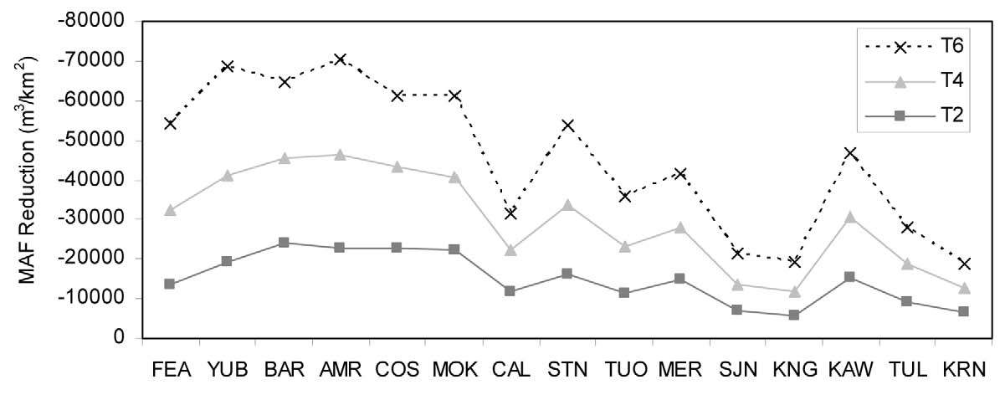
Notes:
MER – Merced River watershed
Source: Null et al. 2010

The modeling also showed that runoff centroid timing (CT) was 2 weeks, 4 weeks, and 6 weeks earlier given the respective 2ºC, 4ºC and 6ºC increases in air temperature. Change in seasonal runoff timing may affect electrical generation capabilities, flood protection, water storage and deliveries. Using online hydropower capacity as a measure of impact, the study identified watersheds vulnerable to CT shifts as they rely on hydropower generation and may face substantial changes in runoff timing with climate warming. Hydropower is often generated during high demand periods, which may be compromised if facilities are forced to spill due to higher magnitude flows or to accommodate early arrival of flows. While the Merced River demonstrated changes in CT due to climate warming, the limited generating capacity of the river (relative to that on other Sierra Nevada rivers) makes it one of the less vulnerable watersheds state-wide.

Figure 4: Average Annual Centroid Timing by Watershed
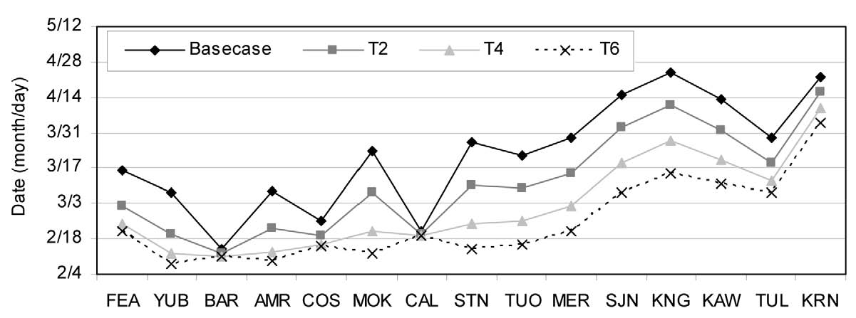
Notes:
MER – Merced River watershed
Source: Null et al. 2010

Finally, the study evaluated the average low flow duration (LFD) for the Sierra Nevada watersheds relative to climate change. For the Merced River, average low flow duration lasted 2, 3 and 4 weeks longer for the 2ºC, 4ºC and 6ºC increases in air temperature, respectively. Changes in LFD were considered a surrogate for montane ecosystems in the study as persistent low flow conditions deplete meadow groundwater reserves and soil moisture, reducing the downstream benefits of meadows. Meadows provide ecosystem services such as maintaining summertime flow during dry periods and reducing floods in winter; providing aquatic and riparian habitat for birds, fish, amphibians, and insects; promoting riparian vegetation rather than conifer or dry shrub vegetation that increases wildfire risks; and improving downstream water quality. Merced River was considered vulnerable to LFD. Along with Yosemite and its meadows upstream, the Merced River could experience habitat loss as a result of climate change.
Figure 5: Average Annual Low Flow Duration by Watershed
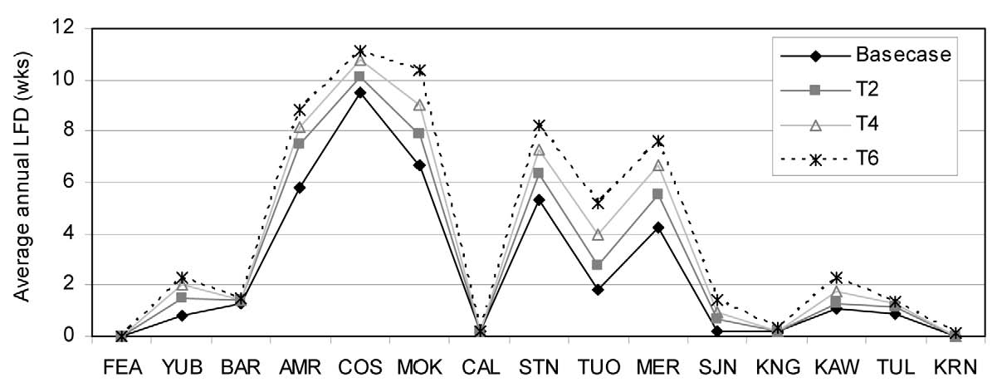
Notes:
MER – Merced River watershed
Source: Null et al. 2010

Regional Water Resource Vulnerability
Primary water users in the Merced IRWM region include urban users, agriculture, and the environment. Water supplies include both groundwater and surface water, with groundwater coming from the Merced (predominantly), Turlock and Chowchilla Subbasins of the San Joaquin Valley Groundwater Basin and surface water being diverted primarily from the Merced, Chowchilla, and San Joaquin Rivers. Declining Sierra Nevada snowpack, earlier runoff, and reduced spring and summer streamflows will likely affect surface water supplies and shift reliance to groundwater resources, which are already overdrafted in many places. This will, in turn, affect critical natural resource issues in the region, such as agricultural land conversion, population growth, air, water and soil quality concerns, and loss of habitat land.
Other anticipated regional impacts resulting from climate change (increased air temperatures and variable precipitation) include changes to water quality; increased flooding, wildfires and heat waves; and impacts to ecosystem health. Earlier springtime runoff will increase the risk of winter flooding as capturing earlier runoff to compensate for future reductions in snowpack would take up a large fraction of the available flood protection space, forcing a choice between winter flood prevention and maintaining water storage for summer and fall dry-period use. Under the ‘business-as-usual’ climate change scenario (A2), wildfires could increase by 100% or more by the end of the century (CNRA 2009). Some of these impacts on water resources management are already being observed within the region.
The identified vulnerabilities within the Merced Region are summarized in Table 1 and further described in the following sections.
Table 1: Merced Region Vulnerabilities
Vulnerability | Description
Water Demand | Vulnerable to increased agricultural demands due to longer growing season, increased temperatures and evapotranspiration rates, and more frequent/severe droughts. Vulnerable to increased urban and commercial, industrial, and institutional (CII) demand due to increased outside temperatures.
Water Supply and Quality | Vulnerable to decreased snowpack in the Sierra Nevada, shifts in timing of seasonal runoff, increased demands exacerbating groundwater overdraft, degraded surface and groundwater quality resulting from lower flows, exaggerated overdraft conditions, a reduction of meadows which can provide contaminant reduction, and more frequent/severe droughts and storm events increasing turbidity in surface supplies.
Flood Management | More severe/flashier storm events and earlier springtime runoff leading to increased flooding, and a reduction of meadows which help reduce floods in the winter.
Hydropower | Vulnerable to increased customer demand combined with changes in timing of seasonal runoff and flashier storm systems affecting reservoir storage.
Ecosystem and Habitat | Vulnerable to decreased snowpack, more frequent/severe droughts and wildfires, shift in seasonal runoff, increased low flow periods and increased water temperatures (degraded water quality).

Water Demand
Land use patterns in the Merced Region are dominated by agricultural uses, including animal confinement (dairy and poultry), grazing, forage, row crops, and nut and fruit trees, all of which rely heavily on water purveyors/districts and private groundwater and surface water supply sources. In general, irrigation water demand varies based on precipitation, and may or may not increase under future climate change conditions. Groundwater pumping is anticipated to increase as more irrigators and agricultural water users turn to groundwater to meet crop water requirements and farming needs (depending on surface water availability), and groundwater salinity increases with decreasing precipitation percolating to groundwater as a result of flashier and more variable precipitation events (Schoups et al. 2005). The effects of increased air temperatures on agriculture will include faster plant development, shorter growing seasons, changes to reference evapotranspiration (ET) and possible heat stress for some crops. Without accounting for evapotranspiration rates, agricultural crop and urban outdoor demands are expected to increase in the Sacramento Valley by as much as 6% in the future (Chung et al. 2009). In addition, fruit crops are more climate-sensitive than other crop types and may require additional water as the climate warms. Therefore, more water may be necessary to maintain yield and quality in future years of apricot or peach crops, for example, in the Merced Region.
If more water is required to maintain yield, and combined with potentially reduced supplies, the agricultural community may respond to these climate-induced changes primarily by increasing the acreage of land fallowing and retirement, augmenting crop water requirements by groundwater pumping, improving irrigation efficiency, and shifting to high-value and salt-tolerant crops (Hopmans et al. 2008). However, agricultural impacts resulting from climate changes are anticipated to be significant as Merced County ranks 5th in the state in agricultural production with a value of over $2.7 billion (Kahrl and Roland-Holst 2008). An example of potential impacts is on dairy production. Heat stress can have a variety of effects on livestock, including reduced milk production and reproduction in dairy cows (Valtorta, 2002). Based on modeling conducted by Hayhoe et al. and presented in their paper entitled Emissions pathways, climate change and impacts on California (Hayhoe et al. 2004), rising temperatures were found to reduce milk production by as much as 7 to 10% under the B1 scenario and by 11 to 22% under the A1 scenario.
Based upon a land use and water demand model created for the Merced Water Supply Plan Update – Final Status Report, the anticipated total water demand in the Merced Subbasin area, which is slightly smaller than the Merced IRWM Region, is anticipated to be 1,160,000 acre-feet (AF) in 2040 (City of Merced, MID, and UC Merced 2001). Table 2 provides an overview of the total anticipated 2040 demand in terms of demand type.
Table 2: Anticipated Total Applied Water Demand in the Merced Subbasin in 2040
Demand Type | Acre-feet | Percentage of Total
Urban | 118,000 | 10%
Agricultural within MID Service Area | 384,000 | 33%
Agricultural outside of MID Service Area | 658,000 | 57%
TOTAL | 1,160,000 | 100%

Groundwater modeling was completed which indicated that groundwater demands are highest during dry years, likely due to the fact that groundwater is primarily used for agricultural irrigation (MAGPI 2002). The seasonal variability of water demands is projected to increase with climate change as droughts become more common and more severe (DWR 2008).
Other seasonal uses such as landscape irrigation cooling demands are also expected to increase as a result of climate change (DWR 2008 and CNRA 2009). Identification of industrial cooling towers and similar facilities will help the region gain better understanding of the potential increases in seasonal demands.

Water Supply and Quality
The Merced IRWM Region’s water supplies include groundwater, local surface water, and imported surface water from the Central Valley Project (CVP). In general, impacts on urban users will be a function of behavioral response of individuals and organizations as well as hydrology (Hayhoe et al. 2004). Additional water storage will be required to ensure water supply reliability. Without additional storage, it will be difficult to capture and retain the extra runoff for use after April 1st without reducing the amount of flood storage space left in reserve. Both the need for empty storage for flood protection and the need for carryover storage for drought protection reflect the uncertainty about future weather conditions and the level of regional risk aversion (Hayhoe et al. 2004).
Currently, approximately 75% of total water use statewide currently occurs between April and September when lawns and crops are being irrigated (Hayhoe et al. 2004). Decreased summertime flows will likely result in increased groundwater pumping (and potential overdraft conditions) due to increased groundwater to offset surface water shortages. Additionally, rising temperatures are projected to increase the frequency of heat waves, which could also lead to increased water use and further exacerbate low flow conditions (Hayhoe et al. 2004).
Changes in water availability and timing will also affect the value of water rights statewide, as mid- and late-season natural stream flow water rights become less valuable and the value of rights to stored water (which has a higher degree of reliability) increase in value. Senior users without access to storage could face unprecedented shortages due to reduced summertime flows (Hayhoe et al. 2004). These same changes will also affect the level of hydropower generation on the Merced River, especially in the summer, when hydropower generation is needed most to meet peak demand (Moser et al. 2012).
Finally, climate change impacts may affect water quality in a multitude of ways.
- Water quality can be impacted by both extreme increases and decreases in precipitation. Increases in storm event severity may result in increased turbidity in surface water supplies while decreases in summertime precipitation may leave contaminants more concentrated in streamflows (DWR, 2008).
- Higher water temperatures may exacerbate reservoir water quality issues associated with reduced dissolved oxygen levels and increased algal blooms (DWR, 2008).

Water quality concerns not only impact drinking water supplies, but also environmental uses and wastewater treatment processes. The altered assimilative capacity of receiving waters may increase treatment requirements, and collection systems could be inundated in flooding events. More prevalent wildfires could result in aerial deposition and runoff of pollutants into water bodies, impacting surface water quality. Declining Sierra Nevada snowpack, earlier runoff and reduced spring and summer stream flows will likely affect surface water supplies and shift reliance to groundwater resources, which are already overdrafted in many places.

Groundwater Supply and Quality
The Merced Region overlies three groundwater subbasins within the San Joaquin Groundwater Basin including the Merced Subbasin in entirety, and portions of the Chowchilla and Turlock Subbasins. According to the 2008 Groundwater Management Plan (GWMP) Update (Amec 2008), groundwater elevations in the Merced Subbasin have been monitored by DWR, MID, and other entities since the 1950s. This monitoring data demonstrates that since 1980 average groundwater levels beneath the Merced Subbasin have declined approximately 14 feet, with most of this decline occurring between 1980 and 1996 (Amec 2008). As such, the Merced Subbasin is considered to be in a state of mild long-term groundwater level decline. In addition to dropping groundwater levels, the Merced Subbasin has high concentrations of total dissolved solids (TDS), generally at depths between 400 and 800 feet below the ground surface, that increase in concentration from east to west. The San Joaquin River acts as a natural saline barrier, so generally, TDS concentrations are greater on the west side of the River and less on the east side. Reduced streamflows in the River could reduce the effect of the natural barrier and allow for further migration of salinity in the groundwater basin. Additionally, climate change impacts may cause increased evapotranspiration and a longer growing season, further exacerbating groundwater overdraft and high salinity levels.
Portions of the groundwater subbasins are subject to high nitrate concentrations; elevated iron and manganese concentrations; and contamination with methyl tert-butyl ether (MTBE), 1,2-dibromo-3-chloropropane (DBCP) and other contaminants; which can impact the beneficial use of groundwater. Lastly, the variation in precipitation and streamflow in the future will influence how and when the groundwater subbasins are recharged in the Merced Region.

Surface Water Supply and Quality
The Central Valley Regional Water Quality Control Board (RWQCB) compiled the 303(d) list of impaired water bodies within the Sacramento River and San Joaquin River Basins that suffer significant water quality impairments from a variety of pollutants and must be addressed through the development of Total Maximum Daily Loads (TMDLs). The Lower Merced River (from McSwain Reservoir to the San Joaquin River) is included on this list. Irrigated agriculture has been identified as a significant anthropogenic source of both nitrate and sediment loading in surface water bodies. Additional sources of sediment loading include erosion, mining, and grazing, among others. Current climate change scenarios project lower stream flows and higher agricultural water use that would pose significant challenges in implementing the defined TMDLs and meeting water quality goals.
As the occurrence of wildfires increases, additional sediment would be deposited into water bodies, and turbidity would likely become more of a concern. Sediment and pollutants collected from upstream could be concentrated downstream, leading to water quality issues and the disturbance of critical habitats. In addition, earlier snowmelt and more intense precipitation events will likely increase turbidity in source waters. Shifts in the timing of runoff have already been observed; over the last one hundred years the fraction of total annual runoff occurring between April and July has decreased by 23% in the Sacramento Basin and by 19% in San Joaquin Basin (CEC 2008). Increased flooding may lead to sewage overflows, resulting in higher pathogen loading in the source waters. Increased water temperatures and shallower reservoirs may result in more prevalent eutrophic conditions in storage reservoirs, increasing the frequency and locations of cyanobacterial blooms. These potential changes could result in challenges for surface water treatment plants and require additional monitoring to quantify changes in source water quality and better control of finished water quality (CUWA 2007).

Imported Surface Water Supply
Only a small portion of Chowchilla Water District (CWD) is within the boundaries of the Merced Region, but it is important to note that imported supplies from the Central Valley Project (CVP) are delivered to CWD through contracts with the United States Bureau of Reclamation (USBR) (Chowchilla Water District, 2012). The contract provides 24,000 acre-feet per year (AFY) from Buchanan Dam and 55,000 AFY of Class 1 Water and 160,000 AFY of Class 2 Water from Friant Dam. As shown in the following figure, the only water district within the Merced Region that receives CVP water is CWD, and it is only partially in the region. Less than 20% of the CWD service area lies within the Region.

Figure 6: CVP Contractors within the Merced Region
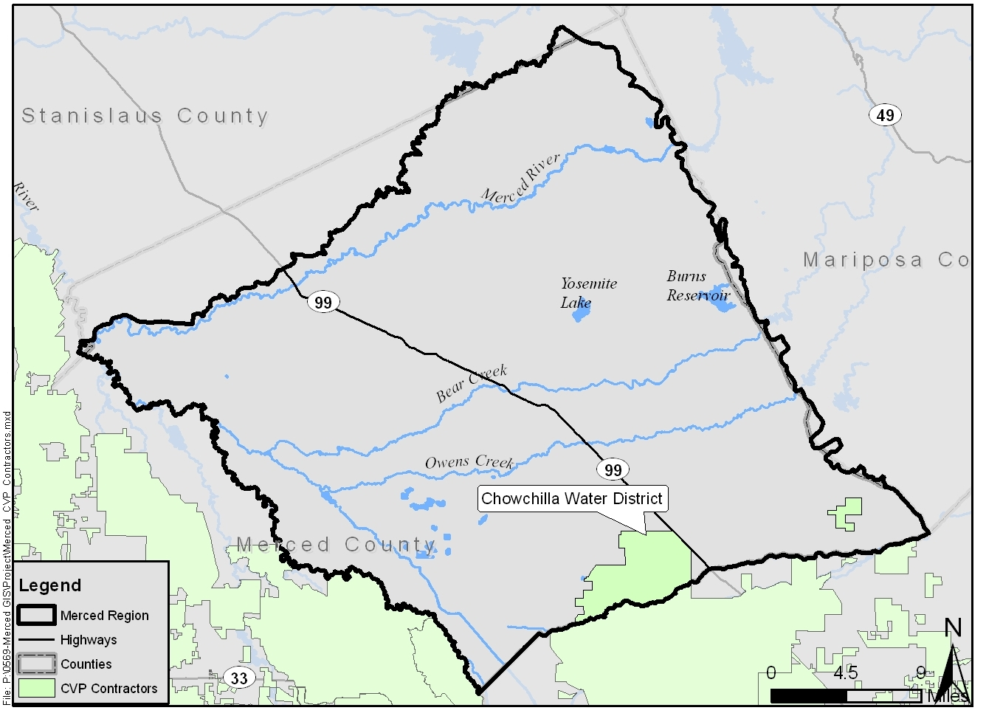

Due to delivery reductions by the USBR, the long-term average annual available CVP supply for agricultural and municipal and industrial (M&I) usage is estimated to be 53% and 83% of the contracted amount, respectively. On December 15, 2008, the U.S. Fish and Wildlife Service (USFWS) released its final Biological Opinion on CVP and State Water Project (SWP) Operations Criteria and Plan (OCAP); the results of this study could also impact the long-term availability of CVP supplies.
As a result of the increased temperature, DWR anticipates a 20% to 40% decrease in the state’s snowpack by mid-century (DWR 2008). This reduction in snowpack impacts the SWP, CVP and water systems that rely on the Colorado River. The SWP 2009 Delivery Reliability Report (DWR 2010c) indicates that Delta exports may be reduced by up to 25% by the end of the century.

Flood Management
Sea level rise is not a direct potential climate change impact to the Merced Region, but if sea level rise occurs, the salinity of the Delta may increase, impacting reservoir operations in the Region and resulting in the potential need for freshwater releases from the Merced River. In addition to increased coastal flooding resulting from sea level rise, severity of non-coastal flooding will also increase in the future due to climate change. Extreme precipitation events will become more common, increasing the likelihood of extreme weather events and floods. Rising snowlines will also increase the surface area in watersheds receiving precipitation as rain instead of snow (DWR 2008), thereby increasing storm-related runoff. The Merced Region experienced two major flood events in recent years (1998 and 2006) that caused significant damage to homes, bridges, roads, and other structures, as well as geomorphic impacts to nearby creeks. These events could increase under anticipated future conditions.
There are significant portions of the Merced Region that lie within the Federal Emergency Management Agency (FEMA) designated 100-year and 500-year flood zones. Low-lying disadvantaged communities (DACs) will be particularly vulnerable to flooding damages causing temporary and/or permanent displacement. Some of the DACs within the Merced region lie within the 100-year floodplain as shown in the following figure.
Figure 7: DACs within 100-year Floodplain
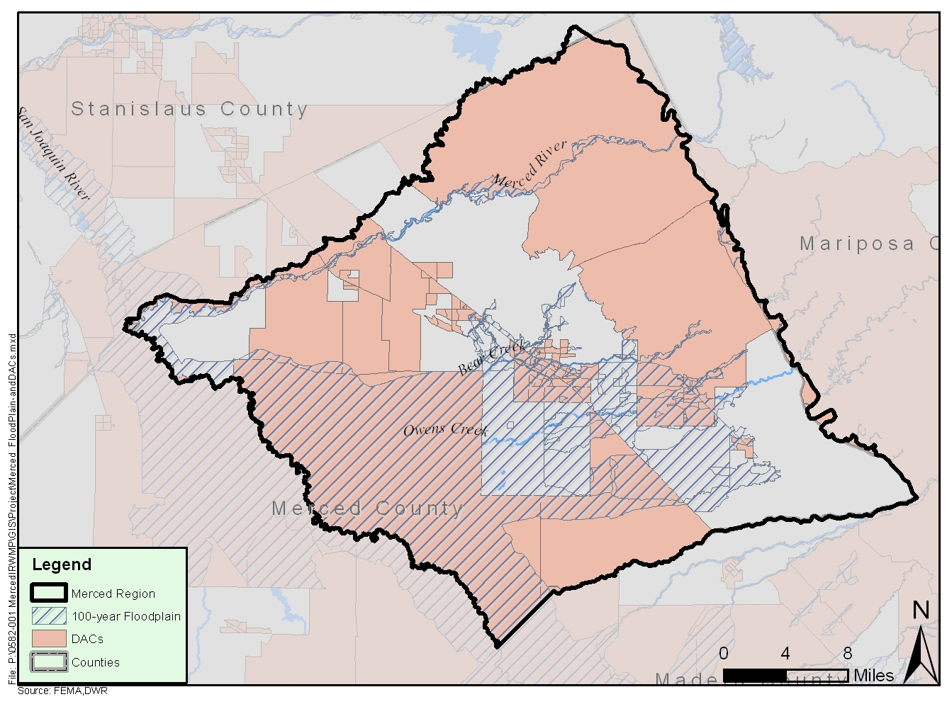

Ecosystem and Habitat
Eastern Merced County supports the largest unfragmented blocks of high-density vernal pool grasslands remaining in California. These vernal pools contain numerous rare and endangered species such as fairy shrimp, tadpole shrimp and several rate Orcutt tribe grasses (Economic & Planning Systems, Inc. 2009b). These species and others that are susceptible to heat waves, droughts, and flooding may be in danger and invasive species may become even more challenging to manage (CCSP 2009).
Climate change impacts on the environment within the Merced Region also include changes in vegetation distribution and increases ecosystem stress. Specifically, temperature-induced declines in alpine/subalpine forests are expected to occur, in addition to major shifts from evergreen conifer forests to mixed evergreen conifer forests and expansion of grasslands (Hayhoe et al. 2004). Increasing stress on ecosystems resulting from rising temperatures will reduce capacity to resist pest attacks while increasing pest survival rates, accelerating their development and allowing them to expand their range. Increasing temperatures will also result in warmer freshwater temperatures which, along with changes in seasonal stream flows, are projected to cause sharp reductions in salmon populations and increased risks of extinction for some Central Valley subpopulations (Ackerman and Stanton 2011).
Projected hotter and possibly drier future conditions will also increase the frequency and extent of wildfires, worsen pest outbreaks, and stress precarious sensitive populations. Wildfires will play a significant role in converting woodlands to grassland as decreases in moisture shift the competitive balance in favor of the more drought-tolerant grasses and increases in grass biomass provide more fine fuels to support more frequent fires. Increased wildfires also favor grasses, which re-establish more rapidly than slower growing woody life forms after burning (Hayhoe et al. 2004)
Finally, decreases in precipitation will directly affect both surface water and groundwater quality. Warmer surface water will result in lower dissolved oxygen concentrations, which can directly impact aquatic and riparian habitats. Decreased precipitation and associated decreased groundwater percolation will result in increased dissolved concentrations of constituents in groundwater.

Hydropower
MID has generated wholesale electric power at its hydroelectric facilities for over 75 years. In 1967, McSwain and New Exchequer Dams were completed in Mariposa County, downstream of Lake McClure. Since then, MID has produced nearly 10 billion kilowatt hours of electricity, equating to an average of approximately 325 million kilowatts per year. Although the hydroelectric facilities and New Exchequer and McSwain Dams are outside the Merced regional boundary, they are operated by MID and provide the region with power. MID operates the Merced River Hydroelectric Project, providing electric services to hundreds of customers in Eastern Merced County (including the cities of Livingston, Atwater, and Merced) utilizing its own transmission lines and substations (MID 2008a). The Hydroelectric Project is operated to provide water supply, flood control, recreation and hydropower. MID holds the original Federal Energy Regulatory Commission (FERC) license for the project, which was issued by the Federal Power Commission, FERC’s predecessor, in 1964 (MID 2008b). The original license expires on February 28, 2014. MID filed an application for a new FERC license in February 2012 and is currently completing the relicensing process.
Lake McClure and the Merced River are supplied primarily by snowmelt from the Sierra Nevada. Changing volumes of snowfall and snowpack in the Sierra Nevada and the changing seasonal melting patterns may require changes in dam operation. As the timing of snowmelt shifts in the spring, hydroelectric power generation may also shift to accommodate enhanced flood control operations. Additionally, increasing temperatures will also increase energy demands, especially during peak demand times (DWR 2008). As previously described, the modeling completed as described in the Hydrologic Response and Watershed Sensitivity to Climate Warming in California’s Sierra Nevada, showed that runoff centroid timing (CT) on the Merced River was 2 weeks, 4 weeks, and 6 weeks earlier given the respective 2ºC, 4ºC, and 6ºC increases in air temperature, respectively. Change in seasonal runoff timing may affect electrical generation capabilities, flood protection, water storage and deliveries. Hydropower is often generated during high demand periods, which may be compromised if facilities are forced to spill due to higher magnitude flows or to accommodate early arrival of flows (Null, et. al. 2010).

Other
Climate change will also affect the Region in other ways, including impacting recreation and tourism industries (and therefore the Region’s economy). As one of the gateways to Yosemite National Park, the City of Merced and surrounding communities rely on this industry as part of its economy. Stressed environments and increased wildfire will put these natural resources at risk. Projections of decreased snowpack have the potential to affect the ski industry as the State’s 34 ski resorts are based between 6,500 and 8,200 feet, well into the elevations impacted by temperature increases. These same temperature increases will also delay the start of ski season and impact the economic viability of the industry (Hayhoe et al. 2004).

Prioritized Vulnerabilities
The Merced Region’s vulnerabilities to anticipated climate changes were prioritized based on discussion with the Regional Water Management Group (RWMG) and the Merced Regional Advisory Committee (RAC) considering regional understanding and sensitivities and identified regional goals and objectives. The prioritized vulnerabilities for the Region were as follows:
- Water Supply/Water Quality
- Flood Management
- Hydropower
- Water Demand
- Ecosystem and Habitat
The rationale behind the prioritization acknowledges that the groundwater basin is already in overdraft condition, and that additional water supply reductions will exacerbate this condition. Similarly, flooding and flood management is a major issue for the Region at present, and a flashier river/stream system is only going to worsen this condition and significantly impact hydropower operations (as would significant changes in river flows resulting from earlier springtime runoff and/or lower annual flows). Increasing water demands will also make the water supply conditions worse. And finally, while ecosystem and habitat issues are important, they derive from the other issues/vulnerabilities (e.g., water supply and quality, which is exacerbated by demand and flood issues), therefore ranking a lower vulnerability.

Adaptation and Mitigation
Global climate modeling carries a significant degree of uncertainty resulting from varying sensitivity to changes in atmospheric forcing (e.g. CO₂, aerosol compounds), unpredictable human responses, and incomplete knowledge about the underlying geophysical processes of global change. Even though current scenarios encompass the “best” and “worst” cases to the greatest degree possible based on current knowledge, significant uncertainty associated with future global GHG emission levels remains, especially as timescales approach the end of the century. The historical data for calibrating GCMs is not available worldwide, and is spatially biased towards developed nations.
Considering the great deal of uncertainty associated with climate change projections, a prudent approach to addressing climate change incorporates a combination of adaptation and mitigation strategies. Climate adaptation includes strategies (policies, programs or other actions) that bolster community resilience in the face of unavoidable climate impacts (CNRA and CEMA 2012), where mitigation strategies include best management practices (BMPs) or other measures that are taken to reduce GHG emissions.
The Prop 84 IRWM Guidelines require consideration of the California Water Plan (CWP) resource management strategies (RMSs) in identifying projects and water management approaches for the region. RMSs are being considered in the Merced IRWM planning process to meet the region’s objectives. Application of various RMSs diversifies water management approaches, and many of the RMSs apply to climate change adaptation and mitigation. Categories of applicable RMSs include:
- Reduce Water Demand
- Improve Operational Efficiency and Transfers
- Increase Water Supply
- Improve Water Quality
- Urban Runoff Management
- Practice Resource Stewardship
- Improve Flood Management
- Other Strategies
Within each RMSs category listed above, a variety of specific RMSs have been identified for the region. For example, reducing water demand can be accomplished through agricultural water use efficiency and/or urban water use efficiency. As described in the Climate Change Handbook for Regional Planning (CDM 2011), not all of the RMSs directly apply to climate change adaptation or mitigation, but are directed at overall system resiliency, which improves a system’s resilience to the uncertain conditions climate change could bring.

Adaptation Strategies
The following table summarizes the ability of individual RMSs to aid in climate change adaption. The application of the RMS that are applicable within the Merced Region as climate change adaptation strategies are described in the following sections.

Reduce Water Demand
Reducing existing and future water demands can reduce pressure on water sources of limited supply and help adapt to the potential climate change impacts of less precipitation, shifting of springtime snowmelt, and overall uncertainty. The Reduce Water Demand RMS includes both agricultural and urban water use efficiency. Opportunities for increased water conservation and water use efficiency measures for urban and agricultural water use are identified in multiple documents including the CWP Update, the Agricultural Efficient Water Management Practices, the California 20x2020 Water Conservation Plan (20x2020 Plan), and by the California Urban Water Conservation Council. These recommendations could potentially be incorporated into the existing framework already developed by cities and water agencies within the Merced Region. Performance metrics that could be used to measure the effectiveness of Reduce Water Demand adaptation include average water demand reduction per year and peak water demand reduction per month (CDM 2011).

Agricultural Water Use Efficiency
The Merced Region is already implementing many agricultural water use efficiency efforts. For example, MID, the Region’s primary agricultural water supplier, has identified and is currently implementing efficient water management practices (EWMPs) as part of its Agricultural Water Management Plan. The Agricultural Water Management Council (AWMC) suggests several EWMPs that include infrastructure upgrades and operational improvements in order to reduce water demand and maintain productivity. The following are some of the EWMPs that the Merced Region could implement:
- Infrastructure Upgrade: Evaporation loss from irrigation ditches and canals is a function of temperature and other climate variables. Depending on different emission scenarios, the operation of these facilities may be impacted by climate change, leading to increased water loss. One of the AWMC EWMPs is to convert irrigation canals and ditches to piping. This water conservation method prevents evaporative losses, which will only increase as temperatures rise. This approach could help the Merced Region adapt to climate change by expanding water supplies and making existing water supplies less vulnerable to climate change impacts. Canal lining is identified as a less capital-intensive method to reduce seepage into the ground, although it does not reduce water evaporation and does reduce groundwater recharge that occurs as a result of this seepage. Canal automation can increase water supply reliability and flexibility to deliver water at the time, quantity, and duration required by the grower, and can facilitate conversion to more efficient irrigation methods such as micro-irrigation (AWMC 2012).

Table 3: Applicability of RMS to Climate Change Adaptation
Resource Management Strategies | Habitat Protection | Flood Control | Water Supply Reliability | Additional Water Supply | Water Demand Reduction | Sea Level Rise | Water Quality Protection | Hydropower
Reduce Water Demand
Agricultural Water Use Efficiency |  |  | ✓ |  | ✓ |  | ✓
Urban Water Use Efficiency |  |  | ✓ |  | ✓ |  | ✓
Improve Operational Efficiency and Transfers
Conveyance-Delta* | ✓ | ✓ | ✓ | ✓ |  | ✓ | ✓
Conveyance-Regional/Local | ✓ | ✓ | ✓ | ✓ |  |  | ✓
System Reoperation |  | ✓ | ✓ | ✓ |  |  |  | ✓
Water Transfers |  |  | ✓ | ✓
Increase Water Supply
Conjunctive Management and Groundwater Storage |  | ✓ | ✓ | ✓ |  |  | ✓
Desalination* |  |  | ✓ | ✓
Precipitation Enhancement* |  |  |  | ✓ |  |  |  | ✓
Recycled Municipal Water |  |  | ✓ | ✓
Surface Storage-CALFED* | ✓ | ✓ | ✓ | ✓ |  |  | ✓ | ✓
Surface Storage-Regional/Local | ✓ | ✓ | ✓ | ✓ |  |  | ✓ | ✓
Improve Water Quality
Drinking Water Treatment and Distribution |  |  | ✓ | ✓ |  |  | ✓
Groundwater Remediation/Aquifer Remediation |  |  | ✓ | ✓ |  |  | ✓
Matching Quality to Use |  |  | ✓ | ✓ |  |  | ✓
Pollution Prevention | ✓ |  | ✓ |  |  |  | ✓
Salt and Salinity Management | ✓ |  | ✓ | ✓ |  |  | ✓
Urban Runoff Management | ✓ | ✓ |  |  |  |  | ✓
Practice Resource Stewardship
Agricultural Lands Stewardship | ✓ | ✓ |  |  | ✓ |  | ✓
Economic Incentives | ✓ | ✓ | ✓ | ✓ | ✓ | ✓ | ✓ | ✓
Ecosystem Restoration | ✓ | ✓ | ✓ |  |  | ✓ | ✓
Forest Management | ✓ | ✓ | ✓ |  |  |  | ✓
Land Use Planning and Management | ✓ | ✓ |  |  |  | ✓ | ✓
Recharge Area Protection |  | ✓ | ✓ | ✓ |  |  | ✓
Water-dependent Recreation | ✓ | ✓ | ✓ |  |  |  | ✓
Watershed Management | ✓ | ✓ | ✓ | ✓ |  | ✓ | ✓ | ✓
Improve Flood Management
Flood Risk Management | ✓ | ✓ |  |  |  | ✓ | ✓ | ✓
Other Strategies
Crop Idling for Water Transfers |  |  | ✓ | ✓ | ✓
Dewvaporation or Atmospheric Pressure Desalination* |  |  |  | ✓
Fog Collection* |  |  |  | ✓
Irrigated Land Retirement |  |  | ✓ |  | ✓
Rainfed Agriculture |  |  |  |  | ✓
Waterbag Transport/Storage Technology* | ✓ |  | ✓ | ✓ |  | ✓ | ✓
* RMS deemed inappropriate for the Merced IRWM Region. See Section 3: RMS Evaluation of the Merced IRWMP for more detail.
- Water Management: Water suppliers and users must take advantage of new technologies and hardware to optimize management of water-related infrastructure. Supervisory control and data acquisition (SCADA) systems enable water managers to collect data to a centralized location and operate automated canals to achieve desired water levels, pressures or flow rate, and also increase the efficiency in reservoir operation. In addition, automated control will free water system operators from manual operation and allow them to plan, coordinate system operations, and potentially reduce costs. Such systems improve communications and provide for flexible water delivery, distribution, measurement, and accounting. On-farm practices can also be improved. Furrow, basin, and border irrigation methods have been improved to ensure that watering meets crop water requirements while limiting runoff and deep percolation. Using organic or plastic mulch can reduce non-essential evaporation of applied water. Advanced irrigation systems include GIS, GPS and satellite crop and soil moisture sensing systems and can all improve overall farm water management (AWMC 2012).

Urban Water Demand Reduction
The 20x2020 Plan includes urban water conservation measures that can be employed to improve water use efficiency. According to the 20x2020 Plan, approximately one third of urban water use is dedicated to landscape irrigation; as such, the greatest potential for urban water use reduction is in reduced landscape irrigation. New landscapes could be designed to be efficient and suitable for the local climate, and existing high-water-using landscapes could be transformed into lower, more efficient alternatives. Weather-based irrigation is a cost-effective measure to improve landscape watering efficiency. Irrigation restrictions can limit landscape irrigation to two days per week or less, encouraging climate-appropriate landscapes and reducing over-irrigation. The 20x2020 Plan also recommends mandating the landscape irrigation BMPs and requiring water-efficient landscapes at all state-owned properties (DWR 2010b).

Improve Operational Efficiency and Transfers
Water supply system operations need to be optimized in order to maximize efficiency. Existing infrastructure for regional and local conveyance, including facilities that connect to the CVP system, must be maintained and improved as their useful lives are reached. Well-maintained conveyance infrastructure improves water supply reliability and enhances regional adaptability to climate change impacts. Addressing aging infrastructure, increasing existing capacity, and/or adding new conveyance facilities can improve existing conveyance systems and operational efficiency.
Through system reoperation, the Merced Region may be able to adapt to less reliable water supplies and/or increased water demands by maintaining conveyance infrastructure, as well as adapting to climate change impacts on hydropower production, flooding, habitat, and water quality.
The Region is currently investigating and implementing water transfers. Specifically, the City of Merced and MID are developing an MOU to formalize the exchange of tertiary-treated wastewater effluent from the City of Merced for surface water from MID. This will help the Region adapt to climate change by providing additional climate resilient water supplies. As such, transfers can improve supply reliability when other supplies are projected to have reduced reliability due to climate change impacts.
An example of a performance metric to quantify this RMS, Improve Operational Efficiency and Transfers, includes amount of new supply created through regional water transfers (CDM 2011).

Increase Water Supply
As water demands increase due to longer growing seasons, higher temperatures, and longer droughts, and the future of existing water supplies sources becomes less certain, the Merced Region will need to enhance existing water supplies to meet demands. Increasing water supply can be accomplished through the implementation of conjunctive management of surface and groundwater supplies as well as through groundwater storage, recycled water use, and increased surface water storage, as appropriate. Diversifying the region’s water supply portfolio and adding drought-resistant sources is an adaptation measure that will help address increased water demands and/or decreased supply reliability. Performance metrics for measuring the effectiveness of the Increase Water Supply RMS could include additional supply created, amount of potable water offset, and supply reliability (CDM 2011).

Conjunctive Management and Surface and Groundwater Storage
Merced Area Groundwater Pool Interests (MAGPI), the Merced RWMG, developed and has been implementing the Merced Groundwater Basin Groundwater Management Plan, which promotes conjunctive surface water and groundwater management to improve the long-term sustainability of the Merced Groundwater Basin. MAGPI was formed an association in 1997 consisting of water purveyors in the Merced Groundwater Basin in addition to Merced County and the East Merced Resources Conservation District, recognizing the potential benefits regional planning would create when considering surface water and groundwater management in the basin. The Merced Region should continue to investigate conjunctive management to increase surface and groundwater use, improve groundwater quality, and adapt to climate change. Increased storage and conjunctive use may increase resilience to shifting runoff patterns, providing more storage for early runoff, reducing or eliminating the potential climate change impacts on flooding and hydropower production, and offsetting decreases in snowpack storage. This strategy is valuable as weather patterns change in frequency and timing and more extreme events occur.
Developing a project to provide additional local surface storage is a possible adaptation strategy for climate change impacts on water supply and associated reliability. Storage provides a way of adjusting a water system to altered peak streamflow timing resulting from earlier snowpack melting. Additional storage capacity could also help the Merced Region adapt to the anticipated increased precipitation variability. Increased surface storage could allow ecosystem and water managers to make real-time decisions that are not available otherwise. It would also facilitate water transfers between basins from upstream reservoirs to receiving regions that have additional storage for the transferred water. Added storage provides greater flexibility for capturing surface water runoff, managing supplies to meet seasonal water demands, helping manage floods from extreme storm events, and adapt to extreme weather conditions such as droughts.
In addition to new storage, agencies could consider the potential to develop water purchasing agreements to buy water from other agencies that own existing storage reservoirs with substantial water supplies. Rehabilitation and possible enlargement of existing dams and infrastructure can potentially eliminate the need for new reservoir storage.
Finally, implementing conjunctive management and groundwater storage can provide benefits similar to additional surface storage, in addition to increased water management flexibility while also reducing groundwater overdraft. There is the potential to bank imported water, flood flows, runoff, recycled water, and/or desalinated water for dry seasons in groundwater basins. Conjunctive management is highly dependent on how well surface water and groundwater are managed as a single source to adapt to the climate system.

Desalination
Because the Merced Region is not a coastal region, desalinating seawater is not an option and therefore not a reasonable climate change adaptation strategy. Desalination of deep connate groundwater is a possibility; however, the potential for land subsidence and brine discharge pose significant challenges to implementing this as a cost-effective adaptation strategy.

Recycled Water Use
The California Recycled Water Policy, developed by the State Water Resource Control Board in 2009, includes a goal of substituting as much recycled water for potable water as possible by the year 2030. Recycled water is a sustainable, climate resilient local water resource that could significantly help the Merced Region meet water management goals and objectives, and assist in meeting the seasonal water demands of agriculture. Water recycling also provides a local supply that generally uses less energy than other water supplies, helping to mitigate climate change impacts through associated GHG emissions. Recycled water will continue to be used for agricultural purposes and urban landscape irrigation, and expanded use will be encouraged and explored.

Improve Water Quality
Improving drinking water treatment and distribution, groundwater remediation, matching water quality to use, pollution prevention, salt and salinity management, and urban runoff management can help improve water quality. These strategies may help a region adapt to drinking water and ecosystem-related water quality impacts from climate change. They may also contribute to providing additional supplies; for example, stormwater capture and reuse would reduce pollution and also provide a seasonal source of irrigation water for urban landscaping or groundwater recharge. Water quality performance metrics for this RMS could include stream temperature, dissolved oxygen content, and pollutant concentrations (CDM 2011).

Drinking Water Treatment and Distribution
Climate change impacts can pose challenges for surface water treatment plants in a number of ways, including increased monitoring and treatment flexibility necessary to quantify and treat for source water quality changes in order to maintain finished water quality. Continued growth statewide will result in increased stress on the limited water resources available for domestic, agricultural, and industrial uses. Improving water treatment technologies and matching quality to end use can provide the flexibility required to meet uncertain future conditions.

Groundwater Remediation
Removing contaminants and pollutant plumes in current groundwater sources will provide additional water supply by allowing an otherwise unusable source to become usable. Combined with matching water quality and quantity to water demand type, this adaptation strategy will help reduce the need for imported water supplies with higher capital costs and greater associated GHG emissions.
Local government and agencies with land use responsibility should limit potentially contaminating activities in areas where recharge takes place (recharge zone protection) and work together with entities currently undergoing long-term groundwater remediation to develop a sustainable, long-term water supply for beneficial reuse.

Pollution Prevention
In recent years, as point sources of pollution have become regulated and controlled, “non-point source” (NPS) pollution has become a primary concern for water managers. NPS pollution is generated from land use activities associated with agricultural development, forestry practices, animal grazing, uncontrolled urban runoff from development activities, discharges from marinas and recreational boating activities, and other land uses that contribute pollution to adjacent surface and groundwater sources.
Pollution prevention and management of water quality impairments should incorporate a watershed approach. DWR recommends the following approach to reduce NPS pollution to existing surface and groundwater sources:
- Establish drinking water source and wellhead protection programs to shield drinking water sources and groundwater recharge areas from contamination.
- Identify communities that rely on groundwater contaminated by anthropogenic sources as their drinking water source and take appropriate regulatory or enforcement action against the responsible party.
- Address improperly destroyed, abandoned, or sealed wells in these communities that may serve as potential pathways for contaminants to reach groundwater.
Protecting water supply sources will help to ensure that long-term sustainability of those supplies.

Salt and Salinity Management
Accumulation of salts in soil can impair crop productivity, making salinity management a critical concern for the Region’s highly productive agricultural industry. Salinity management strategies establish or improve salinity management in the Region based on an understanding of salt loading and transport mechanisms. Several potential benefits of establishing or improving salt and salinity management include protecting water resources and improving water supplies, securing, maintaining, expanding, and recovering usable water supplies, and avoiding future significant costs of treating water supplies and remediating soils. Salt and salinity management strategies identified by the California Water Plan Update 2009 include:
- developing a regional salinity management plan, and interim and long-term salt storage, salt collection, and salt disposal management projects;
- monitoring to identify salinity sources, quantifying the level of threat, prioritizing necessary mitigation action, and working collaboratively with entities and authorities to take appropriate actions;
- reviewing existing policies to address salt management needs and ensure consistency with long-term sustainability; and
- collaborating with other interest groups to optimize resources and effectiveness;
- identifying environmentally acceptable and economically feasible methods for closing the loop on salt.
As part of the Merced IRWM planning process, the region is developing information to support development of a salt and nutrient management plan. This will identify specific salt and salinity challenges within the region and strategies to help adapt to climate change by mitigating potential salinity increases associated with climate change.

Urban Runoff Management
Urban runoff management, including Low Impact Development (LID), encompasses a broad range of activities to manage both stormwater and dry weather runoff. Stormwater capture and reuse projects can reduce the burden on wastewater treatment plants and potable water supplies, helping a region adjust to climate change impacts on water quality and water supply (CDM 2011). The Merced Region should investigate and implement LID techniques and opportunities where appropriate and integrate urban runoff management with other RMSs.

Improve Flood Management
Increased frequency and severity of storm events will require the Merced Region to collaborate and accelerate flood protection projects in order to adapt to increased flooding risks due to climate change. Flood management involves emergency planning, general planning activities, and policy changes. Improving flood management can help a region adapt to not only potential flooding, but many other climate change impacts including ecosystem and water quality vulnerabilities. Performance metrics could include acres of meadows restored or volume of natural flood storage provided (CDM 2011).
The Merced Region, as part of its IRWM planning process, is currently completing an Integrated Flood Study to improve flood management. The Study will help identify strategies to implement to contribute to this RMS and help adapt to climate change impacts.

Structural Improvement
Local flood jurisdictions should establish long-term buyback programs to acquire properties immediately adjacent to levees and other structural facilities to facilitate the eventual removal or relocation of these structures, and enhance the potential for setback levees and floodplain restoration where feasible. Planning for structural projects should be integrated into a comprehensive integrated flood management program that takes a watershed approach (DWR 2009).

Land Use Management
General plans should be updated to reflect increased future flood risks; these should be updated as hydrologic projections change. Land use elements should identify and review flood-prone areas established by FEMA or DWR. Also, revised general plans and regulations should reflect an integrated flood management approach and consider future development on tribal lands.
Local land use agencies should not allow new critical public facilities to be constructed within the 200-year floodplain. Existing critical facilities located in flood-prone areas should be noted in the Emergency Plans prepared by local agencies, with evacuation routes clearly identified.
Promoting the preservation of existing floodplains, restoration of natural floodplain functions where feasible, and careful analysis of the interface between natural floodplains and flood management structures can help prevent erosion and debris deposition from creating undue hazards to downstream facilities and property (DWR 2009).

Disaster Preparedness, Response, and Recovery
The vulnerability assessment previously described helps identify the resources that are most susceptible to climate change impacts. Flood control districts and other relevant jurisdictions should analyze potential flood risks and make this information publicly available. The public should be provided with sufficient information about potential flood risks to make informed decisions that safeguard their lives, property, and critical facilities. Flood control districts should also incorporate the potential effects of climate change into planning for future flood events. Until more refined projections are developed, DWR recommends using a 20% higher peak flow reference for planning purposes (DWR 2009).

Practice Resource Stewardship
Resource stewardship includes overseeing and protecting land, wildlife, and water by way of conservation and preservation, ecosystem restoration and forest management, watershed management, flood attenuation, and water-dependent recreation. Restoring and preserving habitat and wetlands has multiple benefits, including promoting biodiversity and habitat enhancement as well as improved flood management, as the natural storage provided by riparian wetlands can serve as buffers that absorb peak flows and provide slow releases after storm events (DWR 2008). Because the scope of resource stewardship includes all resources, these strategies can help adapt to climate change impacts in various ways, depending on project-specific details (CDM 2011).

Agricultural Resource Stewardship
Counties should adopt agricultural general plan elements and designate supportive agricultural districts that enhance agricultural land stewardship on high priority, productive agricultural lands. The focus of these districts should be for:
- Regulatory assistance through county agricultural ombudsmen;
- Local agricultural infrastructure investment, marketing assistance, and the development of agricultural lands stewardship practices and strategies in cooperation with local, State and federal agricultural conservation entities;
- Land protection instruments, such as the Williamson Act and agricultural conservation easements; and
- Engagement of resource organizations such as resource conservation districts, the American Farmland Trust, and Ag Futures Alliances (via Ag Innovations Network), and be integrated with IRWMPs and HCPs where appropriate.
This recommendation should be implemented over the long-term as each county general plan is updated (CDM 2011).

Ecosystem Restoration
Climate change is predicted to further fragment and shrink California’s ecosystems. Appropriate corrective actions should be designed to expand and reconnect them, preventing or reversing these effects. As water managers in the region identify adaptation strategies for water and flood management, they should consider strategies that will also benefit ecosystems as follows.
- Establish large biological reserve areas that connect or reconnect habitat patches.
- Promote multidisciplinary approaches to water and flood management.
- Expand financial incentives for farmers to grow and manage habitat.
- Improve instream flow needs (CDM 2011).
Improved and enhanced aquatic and riparian habitats can provide significant water resource benefits through promoting groundwater recharge, protecting and improving water quality, and contributing to flood protection.

Forest Management
Although local water agencies that comprise the Merced Region’s RWMG do not have responsibility to manage the upland forested areas that drain to the Region, protection of those lands is important for ensuring high quality surface runoff supplies. Proper forest management would improve water quality, help reduce wildfires, and improve ecosystem and habitat within the Region.
Additional stream gages and precipitation stations upstream of the Region (as well as within the Region itself) could help establish and confirm climate trends and evaluate hydroclimatic and geologic conditions. Water quality and sediment monitoring stations would allow quantification of the effects of climate change as well as forest management activities on surface water quality (CDM 2011).

Other Strategies
Additional conservation and demand reduction measures, such as crop idling, irrigated land retirement, and rainfed agriculture could be implemented as adaptive management strategies under this RMS.

No Regret Strategies
No regret adaptation strategies are those that make sense for current day conditions and the existing water management context, while also helping regions adapt to climate change and anticipated future conditions. The following table presents the No Regrets adaptation strategies for the Merced Region. The region either is already implementing or planning to implement the following No Regret strategies.
Table 4: No Regret Strategies in the Merced Region
Resource Management Strategies | No Regrets Strategy
Agricultural Water Use Efficiency | ✓
Urban Water Use Efficiency | ✓
Conveyance-Delta
Conveyance-Regional/Local
System Reoperation
Water Transfers | ✓
Conjunctive Management and Groundwater Storage | ✓
Recycled Municipal Water | ✓
Surface Storage-Regional/Local
Drinking Water Treatment and Distribution | ✓
Groundwater Remediation/Aquifer Remediation | ✓
Matching Quality to Use | ✓
Pollution Prevention | ✓
Salt and Salinity Management | ✓
Urban Runoff Management
Agricultural Lands Stewardship | ✓
Economic Incentives
Ecosystem Restoration | ✓
Forest Management
Land Use Planning and Management | ✓
Recharge Area Protection | ✓
Watershed Management | ✓
Flood Risk Management | ✓
Crop Idling for Water Transfers
Irrigated Land Retirement
Rainfed Agriculture

Mitigation/GHG Reduction Strategies
The Merced IRWM Region recognizes the importance and value of mitigating climate change by reducing energy use and associated GHG emissions. Water distribution can require significant amounts of energy. In California, 19% of the state’s electricity and 30% of its natural gas is used for water-related activities (DWR 2010a). As the Merced Region solicits and prioritizes projects for inclusion in its IRWM Plan, it must consider GHG emissions from the projects and ways to potentially mitigate climate change.
As described in Section 1.2, increasing GHG concentrations in the Earth’s atmosphere contribute to warming trends and climate change impacts. Because the water industry is a significant contributor to GHG emissions and the overall increasing concentrations in the atmosphere, reducing GHGs generated in the conveyance, treatment, and distribution of water and wastewater poses a significant opportunity to help to achieve the GHG emission goals set by AB32 and reduce GHG emissions generated by water management.
The variation in temperature and precipitation projections from different emissions scenarios illustrates the importance of implementing mitigation measures now to address climate impacts already taking place. GHG emission reductions must be achieved through cooperation at global, national and regional levels to prevent or mitigate continued climate change impacts later in the century. Major components of climate change mitigation strategies include:
- Improve Energy Efficiency
- Reduce Emissions
- Carbon Sequestration
Almost all resource management strategies identified by the 2009 CWP Update can potentially reduce GHG emissions and mitigate climate change impacts. A list of applicable mitigation strategies is included in Table 5.
The following briefly summarizes how the applicable RMS could contribute to climate change mitigation in the Merced Region.
- Reduce Water Demand – implementing urban and agricultural water use efficiency measures will help save water and energy by reducing the volume of water treated and distributed (pumped) throughout regional water systems.
- Improve Operational Efficiency and Transfers – optimizing water system operations will maximize efficiency and potentially reduce energy use. Reducing system losses will also reduce emissions by reducing the volume of water treated and distributed (pumped) throughout regional water systems.
- Increase Water Supply – depending on the method used to increase water supply (e.g. desalination versus increased storage), there may be a net increase or decrease in GHG emissions. Increasing storage could have GHG emissions associated with construction, but relatively low operational emissions.
- Improve Water Quality – GHG emissions depend on the specific project implemented to improve water quality. Matching quality to use generally has lower emissions than using potable water for nonpotable uses. Additionally, protecting water sources from future water quality degradation may offset the future need for water treatment.
- Improve Flood Management – where flood management encourages vegetation growth (e.g. ecosystem or floodplain restoration), carbon sequestration may help reduce net carbon emissions.
- Practice Resource Stewardship – implementing ecosystem restoration or forest management, for example, can contribute to carbon sequestration and potentially reduce net emissions.
- Other Strategies – some of the strategies included under this RMS could reduce GHG emissions by conserving water (i.e., crop idling, irrigated land retirement), whereas others may be more energy-intensive and increase emissions (i.e., dewvaporation, fog collection, and waterbag transport, which were not considered feasible RMSs for the Merced Region).

Table 5: Applicability of CWP Resource Management Strategies to GHG Mitigation
Resource Management Strategies | Greenhouse Gas Mitigation
Resource Management Strategies | Energy Efficiency | Emissions Reduction | Carbon Sequestration
Reduce Water Demand
Agricultural Water Use Efficiency | ✓ | ✓
Urban Water Use Efficiency | ✓ | ✓
Improve Operational Efficiency and Transfers
Conveyance-Regional/Local | ✓ | ✓
System Reoperation | ✓ | ✓
Water Transfers | * | *
Increase Water Supply
Conjunctive Management and Groundwater Storage | * | *
Recycled Municipal Water | * | *
Surface Storage-Regional/Local | * | ✓
Improve Water Quality
Drinking Water Treatment and Distribution | ✓ | ✓
Groundwater Remediation/Aquifer Remediation | * | *
Matching Quality to Use | * | *
Pollution Prevention |  | ✓
Salt and Salinity Management |  | ✓
Urban Runoff Management | ✓ | ✓
Improve Flood Management
Flood Risk Management |  |  | ✓
Practice Resource Stewardship
Agricultural Lands Stewardship |  |  | ✓
Economic Incentives | ✓ | ✓ | ✓
Ecosystem Restoration |  |  | ✓
Forest Management |  |  | ✓
Land Use Planning and Management | ✓ | ✓ | ✓
Recharge Area Protection |  |  | ✓
Water-dependent Recreation |  | ✓
Watershed Management | ✓ | ✓ | ✓
Other Strategies
Crop Idling for Water Transfers | ✓ | ✓
Irrigated Land Retirement | ✓ | ✓
Rainfed Agriculture | ✓ | ✓ | ✓
Source: modified from CDM 2011
Key:
✓ indicates that in general this will provide a beneficial effect
X indicates that in general this will provide an adverse effect
* indicates that this may provide beneficial or adverse effects

Plan for Further Data Gathering
Identifying and implementing appropriate adaptation strategies requires having the data necessary to (1) understand the magnitude of climate change impacts and associated vulnerabilities and (2) plan for strategy implementation in a timely manner. To aid in this understanding, the Merced Region has developed a data gathering and analysis approach to collecting and assimilating data related to the prioritized climate change vulnerabilities.
As an umbrella document, the Merced IRWM Plan is intended to coalesce and build upon available planning information and studies, not supersede them. Currently, significant data collection efforts are underway at the state, national, and international levels by agencies including DWR, the California Air Resources Board (CARB), the US Environmental Protection Agency (EPA), and the International Panel on Climate Change (IPCC), among others. In order to ensure that the MAC Plan is responsive to projected climate change impacts and prioritized vulnerabilities, it will be critical to assimilate the data and information being collected through these avenues into future Plan updates. Further, a variety of project-specific data and information will be collected as part of the project performance and monitoring program. This data could contribute additional information on climate change information on the regional level that could be used to augment information developed at the state and national levels.
In conjunction with future MAC IRWM Plan updates, the available body of climate change information, data, and literature will be evaluated and incorporated into the vulnerabilities analysis and throughout the Plan, as appropriate. In addition, the data collection tables completed in support of the Plan-level and project-level monitoring will be revised, as appropriate, to include additional climate change parameters.
At a minimum the following data collection and analysis actions will be implemented as part of future plan updates to ensure that the plan adequately addresses prioritized climate change vulnerabilities:
- Review statewide available data at the following sites:
  - DWR IRWM Climate Change Document Clearinghouse – http://www.water.ca.gov/climatechange/docs/IRWM-ClimateChangeClearinghouse.pdf
  - DWR’s Climate Change Website – http://www.water.ca.gov/climatechange
  - Climate Change Handbook – http://www.water.ca.gov/climatechange/CCHandbook.cfm
  - State of California Climate Change Portal – http://www.climatechange.ca.gov
  - CARB website – http://www.arb.ca.gov/cc/cc.htm
  - The California CAT website – http://climatechange.ca.gov/climate_action_team/index.html
  - CEQA Greenhouse Gas Analysis Guidance for DWR Grantees – http://www.water.ca.gov/climatechange/docs/Guidance%20For%20Grantees-%20Calculating%20GHGs%20for%20CEQA2011.pdf
  - Association of Environmental Professionals. 2007. Alternative Approaches to Analyzing Greenhouse Gas Emissions and Global Climate Change in CEQA Documents. http://www.counties.org/images/public/Advocacy/ag_natres/AEP_Global_Climate_Change_June_29_Final%5B1%5D.pdf
  - California Climate Action Registry. (2009). General Reporting Protocol Version 3.1. http://www.climateregistry.org/resources/docs/protocols/grp/GRP_3.1_January2009.pdf
  - California Climate Adaptation Planning Guide – http://resources.ca.gov/climate_adaptation/local_government/adaptation_policy_guide.html
  - Center for Biological Diversity. 2007. The California Environmental Quality Act on the Front Lines of California’s Fight Against Global Warming. http://www.biologicaldiversity.org/publications/papers/CBD-CEQA-white-paper.pdf
- Review national and international data at the following sites:
  - U.S. EPA. 2009. Inventory of U.S. Greenhouse Gas Emissions and Sinks 1990-2007. http://www.epa.gov/climatechange/ghgemissions/usinventoryreport.html
  - World Resources Institute and World Business Council for Sustainable Development. N.d. The Greenhouse Gas Protocol for Project Accounting. http://www.wri.org/publication/greenhouse-gas-protocol-ghg-protocol-project-accounting
  - Update plan performance monitoring and project-specific monitoring data collection tables to include climate change parameters as appropriate.

References
Ackerman, Frank and Elizabeth A. Stanton. 2011. The Last Drop: Climate Change and the Southwest Water Crisis. Stockholm Environmental Institute – U.S. Center. February.
Amec Geomatrix, Inc. 2008. Merced Groundwater Basin, Groundwater Management Plan Update, Merced County, CA. July 29.
Boyle Engineering Corp. 2006. City of Atwater 2005 Urban Water Management Plan (Administrative Draft). April.
Bureau of Reclamation (BOR). 2011. SECURE Water Act Section 9503(c) – Reclamation Climate Change and Water, 2011. April.
California Air Resources Board (CARB). 2011. Attachment D, Final Supplement to the AB 32 Scoping Plan Functional Equivalent Document. August 19.
California Climate Action Team (CAT), Water-Energy Sector Sub Group. 2009. Water-Energy Sector Summary, AB 32 Scoping Plan, GHG Emissions Reduction Strategies. March 4.
California Department of Water Resources (DWR). 2012a. Proposition 84 & 1E Integrated Regional water Management Draft Guideline. July.
DWR. 2012b. State Water Project Delivery Reliability Report 2011. June.
DWR. 2012c. Draft Climate Action Plan. March.
DWR. 2010a. Proposition 84 & 1E Integrated Regional water Management Guidelines. August.
DWR 2010b. 20x2020 Water Conservation Plan. February.
DWR. 2010c. State Water Project Delivery Reliability Report 2009.
DWR. 2009. California Water Plan Update 2009 - Integrated Water Management. DWR Bulletin 160-09.
DWR. 2008. Managing an Uncertain Future: Climate Change Adaptation Strategies for California’s Water. October.
DWR. 2006. Progress on Incorporating Climate Change into Management of California’s Water Resources. Technical Memorandum Report. Accessed April 24, 2011.
California Energy Commission (CEC) Public Interest Energy Research Program (PIER). 2008. The Future Is Now: An Update on Climate Change Science, Impacts, and Response Options for California. Publication # CEC-500-2008-077.
California High-Speed Rail Authority. 2012. California High-Speed Train Project Environmental Impact Report/Environmental Impact Statement, Final, Merced to Fresno Section Project EIR/EIS, Volume II, Technical Appendices, Appendix 3.6-A, Water Consumption Technical Memorandum. Technical memorandum addressed to Ann Koby and Bryan Porter from Erik Fanselau and Jeff Nelson entitled “Water Usage Analysis for HST Merced to Fresno Section”. February 20.
California Natural Resources Agency (CNRA) and the California Emergency Management Agency (CEMA). 2012. Draft California Climate Change Adaptation Policy Guide. April.
CNRA. 2009. 2009 California Climate Change Adaptation Strategy: A Report to the Governor of the State of California in Response to Executive Order S-13-2008. As viewed at http://www.climatechnage.ca.gov/adaptation/
California State Assembly. 2006. Assembly Bill No. 32 (Chapter 488).
California State Senate. 2007. Senate Bill No. 97 (Chapter 185).
California State Senate. 2008. Senate Bill No. 375 (Chapter 728).
Camp Dresser McKee. 2011. Climate Change Handbook for Regional Water Planning. Prepared for the U.S. Environmental Protection Agency Region 9 and the California Department of Water Resources. November.
Carollo. 2011. City of Merced, 2010 Urban Water Management Plan. June.
Carollo. 2007. City of Livingston 2005 Urban Water Management Plan. March.
Cayan, Dan, Mary Tyree, Mike Dettinger, Hugo Hidalgo, Tapash Das, Ed Maurer, Peter Bromirski, Nicholas Graham and Reinhard Flick. 2009. Climate Change Scenarios and Sea Level Rise Estimates for the California 2009 Climate Change Scenarios Assessment. CED-500-2009-014-F. California Climate Change Center. As viewed at www.energy.ca.gov/2009publications/CEC-500-2009-014/CEC-500-2009-014-D.pdf
Cayan, Dan. Amy Lynd Luers, Michael Hanemann, Guido Franco, Bart Croes. 2006. Scenarios of Climate Change in California: An Overview. California Energy Commission publication CEC-500-2005-186-SF.
CH2M HILL. 2001. Final Status Report, Water Supply Plan Update. September.
Chowchilla Water District. 2012. As viewed at http://cwdwater.com/index.php/about-cwd-2/water-resources on September 7.
Chung, F., J. Anderson, S. Arora, M. Ejeta, J. Galef, T. Kadir, K. Kao, A. Olson, C. Quan, E. Reyes, M. Roos, S. Seneviratne, J. Wang, H. Yin. 2009. Using Future Climate Projections to Support Water Decision Making in California. California Energy Commission publication CEC-500-2009-52-F.
City of Merced, Development Services. 2012. Climate Action Plan. Public Review Draft, prepared by Planning Staff after June 4, 2012 City Council Meeting. August 3.
City of Merced, Development Services. 2011. Climate Action Plan, Background Report. January 6.
Congressional Budget Office (CBO). 2009. Potential Impacts of Climate Change in the United States. May.
City of Merced, Merced Irrigation District, and University of California, Merced (City of Merced, MID, and UC Merced). 2001. Merced Water Supply Plan Update – Final Status Report. September 2001.
California Urban Water Agencies (CUWA). 2007. Climate Change and Urban Water Resources.
East Merced Resource Conservation District and Stillwater Sciences. 2008. Merced River Alliance Project, Final Report, Volume I, Project Overview, Outreach and Education. September.
Economic & Planning Systems, Inc. 2012. Final Report, City of Los Banos Municipal Service Review. March 22.
Economic & Planning Systems, Inc. 2010a. Final Report, City of Dos Palos Municipal Service Review. March 25.
Economic & Planning Systems, Inc. 2010b. Final Report, City of Atwater Municipal Service Review. April 22.
Economic & Planning Systems, Inc. 2009a. Final Report, County of Merced, Cemetery Districts Municipal Service Review. April 23.
Economic & Planning Systems, Inc. 2009b. Final Report, County of Merced, Resource Conservation Districts Municipal Service Review. April 23.
Economic & Planning Systems, Inc. 2009c. Final Report, County of Merced, Special Services Districts Municipal Service Review. June 25.
Economic & Planning Systems, Inc. 2008. Final Report, County of Merced, Agricultural Irrigation Service Providers Municipal Service Review. October 23.
Economic & Planning Systems, Inc. 2007. Final Report, County of Merced, Water and Sewer Service Providers Municipal Service Review. May 24.
Economic & Planning Systems, Inc. 2005a. Final Report, City of Livingston Municipal Service Review. January 27.
Economic & Planning Systems, Inc. 2005b. Final Report, City of Gustine Municipal Service Review. April 28.
Economic & Planning Systems, Inc. 2004. Final Report, City of Merced Municipal Service Review. July 22.
Fishbio Environmental, LLC. 2007. San Joaquin Basin, Merced River. As viewed at http://sanjoaquinbasin.com/merced-river.html on August 27, 2012.
Galloway, Devin L. and Francis S. Riley. 1999. San Joaquin Valley, California - Largest human alteration of the Earth’s surface. In Land Subsidence in the United States. U.S. Geological Survey Circular 1182, pp. 23-34, http://pubs.usgs.gov/circ/circ1182/, accessed Feb. 13, 2009.
Hayhoe, Katharine, Daniel Cayan, Christopher B. Field, Peter C. Frumhoff, Edwin P. Maurer, Norman L. Miller, Susanne C. Moser, Stephen H. Schneider, Kimberly Nicholas Cahill, Elsa E. Cleland, Larry Dale, Ray Drapek, R. Michael Hanemann, Laurence S. Kalkstein, James Lenihan, Claire K. Lunch, Ronald P. Neilson, Scott C. Sheridan and Julia H. Verville. 2004. Emissions Pathways, climate change and impacts on California. Published in the Proceedings of the National Academy of Sciences of the United States of America, Volume 101, Number 34. August 24. pp 12422-12427.
Hopmans, Jan, Gerrit Schoups, and Ed Maurer. 2008. Global Warming and its Impacts on Irrigated Agriculture in the San Joaquin Valley (SJV). As viewed at https://sunsite.berkeley.edu/WRCA/WRC/pdfs/GW26thHopmans.pdf. August 22.
Howatt, Ian M. and Slawek Tulaczyk. 2005. Climate sensitivity of spring snowpack in the Sierra Nevada. As seen in the Journal of Geophysical Research, Volume 110, F04021, 9 pp. December 8.
Howitt, Richard, Josué Medellin-Azuara, and Duncan MacEwan. 2009. Estimating the Economic Impacts of Agricultural Yield Related Changes for California. CED-500-2009-042-F. California Climate Change Center, as viewed at http://www.energy.ca.gov/2009publications/CED-500-2009-042/CED-500-2009-042-F.pdf
Intergovernmental Panel on Climate Change (IPCC). 2007. Climate Change 2007: Synthesis Report.
Kahrl, Fredrich and David Roland-Holst. 2008. California Climate Risk and Response. November.
Leung, L. Ruby, and William I. Jr. Gustafson. 2005. Potential Regional Climate Change and Implications to U.S. Air Quality. As published in the Geophysical Research Letters, 32:L16711.
Loáiciga, Hugo A. 2003. Climate Change and Groundwater. As published in the Annals of the Association of American Geographers. 93(1), pp 30-41.
Lobell, David B., Kimberly Nicholas Cahill, and Christopher B. Field. 2007. Historical effects of temperature and precipitation on California Crop Yields. As published in Climate Change, 81:2, pp187-203. As viewed at http://www.escholarship.org/uc/item/3d53x9mc
Lobell, David B., Kimberly Nicholas Cahill, and Christopher B. Field. 2006. Weather-based yield forecasts developed for 12 California Crops. As published in California Agriculture, 60:4, pp211-15. As viewed at http://dx.doi.org/10.1007/s1-10584-006-9141-3
Lundquist, Jessica D., Michael D. Dettinger, and Daniel R. Cayan. 2005. Snow-fed streamflow timing at different basin scales: Case study of the Tuolumne River above Hetch Hetchy, Yosemite, California. As published in Water Resources Research, Volume 41, July 7.
Lundquist, Jessica D. and Daniel R. Cayan. 2002. Seasonal and Spatial Patters in Diurnal Cycles in Streamflow in the Western United States. As published in Journal of Hydrometerology, by the American Meterological Society, Volume 3, pp. 591-603. October.
Merced Area Groundwater Pool Interest (MAGPI). 2002. Data Assessment Report for the Merced Groundwater Basin. August 2002.
Merced Area Groundwater Pool Interests (MAGPI). 1997. Merced Groundwater Basin Groundwater Management Plan. December 30.
Merced County. 2011. 2030 Merced County General Plan Update, Water Element. Planning Commission Review Draft, Part II: Countywide Goals, Policies and Programs. February 15.
Merced County. 2010. Merced Vision 2030 Genera Plan, Draft Program Environmental Impact Report. August.
Merced Irrigation District. 2012. Merced River Hydroelectric Project, Application for New License. FERC Project No. 2179. February.
Merced Irrigation District. 2009. Migration Timing of Adult Chinook Salmon into the Merced River. Draft. July 15.
Merced Irrigation District. 2008a. Power Generation. A Long Tradition of Generating Power. Accessed at http://www.mercedid.org/history on September 18, 2012.
Merced Irrigation District. 2008b. Hydro. Accessed at http://www.mercedid.org/hydro on September 18, 2012.
Merced Irrigation District. 2003. Water Management Plan. May 6.
Merced Irrigation District. 1997. Groundwater Management Plan. January 7.
Moser, Susanne, Julia Ekstrom and Guido Franco. 2012. Our Changing Climate 2012, Vulnerability & Adaptation to the Increasing Risks from Climate Change in California. A Summary Report on the Third Assessment from the California Climate Change Center. CEC-500-2012-007. July.
National Marine Fisheries Service. 2009. Public Draft Recovery Plan for the Evolutionarily Significant Units of Sacramento River Winter-Run Chinook Salmon and Central Valley Spring-Run Chinook Salmon and the District Population Segment of Central Valley Steelhead. October.
Nolte Associates. 2009. Merced County General Plan Update, Qualitative Comparison of Water Supply and Demands in Merced County, Draft Technical Memorandum. November.
Null, Sarah E., Joshua H. Viers, and Jeffery F. Mount. 2010. Hydrologic Response and Watershed Sensitivity to Climate Warming in California’s Sierra Nevada. April 1.
Schlenker, Wolfram, W. Michael Hanemann, and A. C. Fisher. 2007. Water availability, degree days and the potential impact of climate change on irrigated agriculture in California. As viewed in Climate Change, 81:1, pp 19-38. As viewed at http://dx.doi.org/10.1007/s10584-005-9008-z
Schoups, Gerrit, Ed Maurer, and Jan Hopmans, et al. 2009. Climate Change Impacts on Subsurface Hydrology, Crop Production, Water Use and Salinity in the San Joaquin Valley, CA. As presented at the DWR-UC Workshop on Climate Change Impacts, January 26.
Schoups, G., E.P. Maurer and J.W. Hopmans. 2005. Climate change impacts on water demand and salinity in California’s irrigated agriculture.
Stillwater Sciences. 2008. Merced River Alliance Project, Final Report, Volume II, Biological Monitoring and Assessment. September.
Stoddard & Associates. 2003. City of Gustine Year 2002 Water Master Plan. February.
Treidel, Holger, Jose Luis Martin-Bordes, and Jason J. Gurdak (ed.). 2012. Climate Change Effects on Groundwater Resources, A Global Synthesis of Findings and Recommendations. CRC Press.
United States Climate Change Science Program (CCSP). 2009. Best Practice Approaches for Characterizing, Communicating, and Incorporating Scientific Uncertainty in Decision Making. Synthesis and Assessment Product 5.2. January.
CCSP. 2008. Weather and Climate Extremes in a Changing Climate. Regions of Focus: North American, Hawaii, Caribbean and U.S. Pacific Islands. Synthesis and Assessment Product 3.3. June.
United States Environmental Protection Agency (USEPA). 2012a. Climate Ready Water Utilities Adaptation Strategies Guide for Water Utilities. EPA 817-K-11-003. January.
USEPA. 2012b. Planning for Sustainability, A Handbook for Water and Wastewater Utilities. EPA-832-R-12-001. February.
USEPA. 2012c. National Water Program 2012 Strategy: Response to Climate Change, Public Comment Draft. March.
United States Geological Survey (USGS), Office of Global Change. 2009. Effects of Climate Variability and Change on Groundwater Resources of the United States. Fact Sheet 2009-3074. September.
University of California, Davis. 2012. Vulnerability and Adaptation to Climate Change in California Agriculture. A White Paper from the California Energy Commission’s California Climate Change Center. CEC-500-2012-031. July.
Valtorta, Silvia. 2002. Animal production in a changing climate: impacts and mitigation. October.
WRIME. 2007. Merced Basin Hydrologic Modeling Objectives and Strategy. February.

